|  |  |
| --- | --- |
| **QUESTION** | **Application** |
| **SC1.1** | **Is the Temporary Silt Fence applied as required - temporary linear barrier (perimeter control)?** |
| **CGP, Attachment C.E.1, D.E.1, E.E.1** | Risk Level 1, 2 and 3 dischargers shall establish and maintain effective perimeter controls and stabilize all construction entrances and exits to sufficiently control erosion and sediment discharges from the site. |
| **LTP, Section VIII.B** | Dischargers shall implement a combination of sediment and erosion controls to prevent or minimize sediment discharges from the site. Control measures shall include, but are not limited to, the following items:  **1.** Install temporary sediment controls for the down-gradient perimeter of the project site, and/or any location where storm water or authorized nonstorm water may discharge from the project site, prior to the initiation of any construction-related activities. |

|  |  |
| --- | --- |
|  | **Installation** |
| **SC1.2** | **Is the Temporary Silt Fence or Temporary Reinforce Silt Fence installed properly?** |
| **SPECs, 13-10.03A General** | Before installing a temporary linear sediment barrier, remove obstructions, including rocks, clods, and debris greater than 1 inch in diameter from the ground. |
| **SPECs, 13-10.03E Temporary Reinforced Silt Fences** | Place a temporary reinforced silt fence parallel with the slope contour. For any 50-foot section of reinforced silt fence, do not allow the elevation at the base of the fence to vary by more than 1/3 of the fence height.  Install temporary reinforced silt fence as follows:  1. Dig a 6-inch deep trench.  2. Place the wire mesh and the bottom of the silt fence fabric in the trench.  3. Place posts on the downhill side of the fabric and wire mesh.  4. Attach the silt fence fabric to the wire mesh with tie wires or locking plastic fasteners along the length of the fence at not more than 3-foot horizontal spacing and from top to bottom at not more than 8-inch vertical spacing.  5. Backfill the trench with soil by hand or mechanical tamping to secure the silt fence fabric and the wire mesh in the trench.  6. Attach guy wires and anchors at each post. Install at least 2 anchors and guy wires at angle points and end posts.  Connect sections of temporary reinforced silt fence as follows:  1. Join separate sections of the silt fence to form reaches not more than 500 feet long. Each section must be a continuous run of silt fence from end-to-end or from an end to an opening, including joined panels.  2. Secure the end posts of each section by wrapping the tops of the posts with at least 2 wraps of 16-gauge tie wire.  If temporary reinforced silt fence Type 1 is shown, attach high-visibility fabric to the steel posts by using tie wires or locking plastic fasteners. |
| **SPECs, 13-10.03F Temporary Silt Fences** | Construct a temporary silt fence with silt fence fabric, posts, and fasteners assembled at the job site or with prefabricated silt fence.  If prefabricated silt fence is used, attach the fabric to the posts by inserting the posts into the sewn pockets. If assembled at the job site:  1. Fasten the fabric to the posts with staples or nails if wood posts are used  2. Fasten the fabric to the posts with tie wires or locking plastic fasteners if steel posts are used  3. Space the fasteners not more than 8 inches apart  Place temporary silt fence parallel with the slope contour. For any 50-foot section of temporary silt fence, do not allow the base elevation of the fence to vary by more than 1/3 of the height of the fence above the ground.  Install a temporary silt fence as follows:  1. Place the bottom of the fabric in a 6-inch deep trench  2. Secure it with the posts placed on the downhill side of the fabric  3. Backfill the trench with soil and compact by hand or mechanical methods to secure the fabric in the trench  Connect sections of a temporary silt fence as follows:  1. Join separate sections of the silt fence to form reaches not more than 500 feet long. Each section must be a continuous run from end-to-end or from an end to an opening, including joined panels.  2. Secure the end posts of each section by wrapping the tops of the posts with at least 2 wraps of 16 gauge tie wire.  You may install the silt fence by mechanically pushing the silt fence fabric vertically into the soil. Mechanically installed fabric must not slip out of the soil or allow sediment to pass under the fabric. |
| **See Standard Plan Sheet T51** | Temporary Silt Fence |
| **See Standard Plan Sheet T60** | Temporary Reinforced Silt Fence |

|  |  |
| --- | --- |
|  | **Materials** |
| **SC1.3** | **Does the Temporary Silt Fence or Temporary Reinforced Silt Fence consist of the proper materials (fabric, posts)?** |
| **SPECs, 13-10.02C Posts** | Posts must be wood or metal.  Wood posts must be:  1. At least 2 by 2 inches in size and 4 feet long  2. Untreated fir, redwood, cedar, or pine, cut from sound timber  3. Straight and free of loose or unsound knots and other defects that could render the posts unfit for use  4. Pointed on the end to be driven into the ground  Metal posts must:  1. Be at least 4 feet long.  2. Be made of steel.  3. Have a U-shaped, T-shaped, L-shaped, or other cross-sectional shape that can resist failure from lateral loads.  4. Be pointed on the end to be driven into the ground.  5. Weigh at least 0.75 pound per foot.  6. Have a safety cap attached to the exposed end. The safety cap must be orange or red plastic and must fit snugly onto the metal post.  Posts for a temporary reinforced silt fence must be at least 6 feet in length for a Type 1 installation and 5 feet in length for a Type 2 installation. |
| **SPECs, 13-10-02D High Visibility Fence** | High visibility fabric must contain UV inhibitors and comply with the requirements in the following table:   |  |  |  | | --- | --- | --- | | **Property** | **Specifications** | **Value** | | Width, inches, min | Measured | 48 | | Opening size inches | Measured | 1” x 1” (min)  2” x 4” (max) | | Color | Observed | Orange | | Roll weight, lb, min for 4’ x 100’ roll | Measured | 12 | |
| **SPECs, 13-10.02E Wire Mesh** | Wire mesh for a temporary reinforced silt fence must comply with section 80-2.02E, be fabricated from at least 14-gauge horizontal and vertical wires welded at each intersection, and have a maximum opening 2 inches wide by 4 inches high. The fence must be supplied in 50-foot rolls. |
| SPECs, 13-10.02F Wire | Wire for guy wires and tie wires for a temporary reinforced silt fence must be 16-gage iron or steel. |
| SPECs, 13-10.02G Anchors | Anchors for a temporary reinforced silt fence must be fabricated from no. 4 steel reinforcing bar. |
| SPECs, 80-2.02E Wire Mesh | Wire mesh must:  2. Be 32 inches wide  3. Have 8 horizontal wires with vertical stays spaced 6 inches apart  The top and bottom wires must be 10-gauge. The intermediate wires and vertical stays must be 12-1/2 gauge. |

|  |  |
| --- | --- |
|  | **Maintenance** |
| **SC1.4** | **Is the Temporary Silt Fence or Temporary Reinforced Silt Fences maintained properly?** |
| **SPECs, 13-10.03A General** | Maintain a temporary linear sediment barrier to provide sediment-holding capacity and to reduce concentrated flow velocities.  Repair or adjust the barrier whenever rills and other evidence of concentrated runoff are occurring beneath the barrier.  Repair or replace split, torn, or unraveled material. Add or replace posts, stakes, or fasteners as needed to prevent sagging or slumping.  Whenever a barrier becomes detached or dislodged from the pavement, reattach it.  Remove sediment deposits, trash, and other debris as needed or ordered.  Remove sediment deposits whenever the sediment exceeds:  1. 1/3 of the height above ground behind a fence  Whenever you place the removed sediment deposits within the job site, stabilize the sediment deposits to prevent erosion. |
| **CGP, Attachment C.E.1, D.E.1, E.E.1** | Risk Level 1, 2 and 3 dischargers shall establish and maintain effective perimeter controls and stabilize all construction entrances and exits to sufficiently control erosion and sediment discharges from the site. |
| **CGP, Attachment D.E.6; E.E.6** | Risk Level 2 and 3 dischargers shall ensure that all storm drain inlets and perimeter controls, runoff control BMPs, and pollutant controls at entrances and exits (e.g. tire washoff locations) are maintained and protected from activities that reduce their effectiveness. |
| **CGP, Order IV.E Proper Operation and Maintenance** | The discharger shall at all times properly operate and maintain any facilities and systems of treatment and control (and related appurtenances) which are installed or used by the discharger to achieve compliance with the conditions of this General Permit. Proper operation and maintenance also includes adequate laboratory controls and appropriate quality assurance procedures. Proper operation and maintenance may require the operation of backup or auxiliary facilities or similar systems installed by a discharger when necessary to achieve compliance with the conditions of this General Permit. |

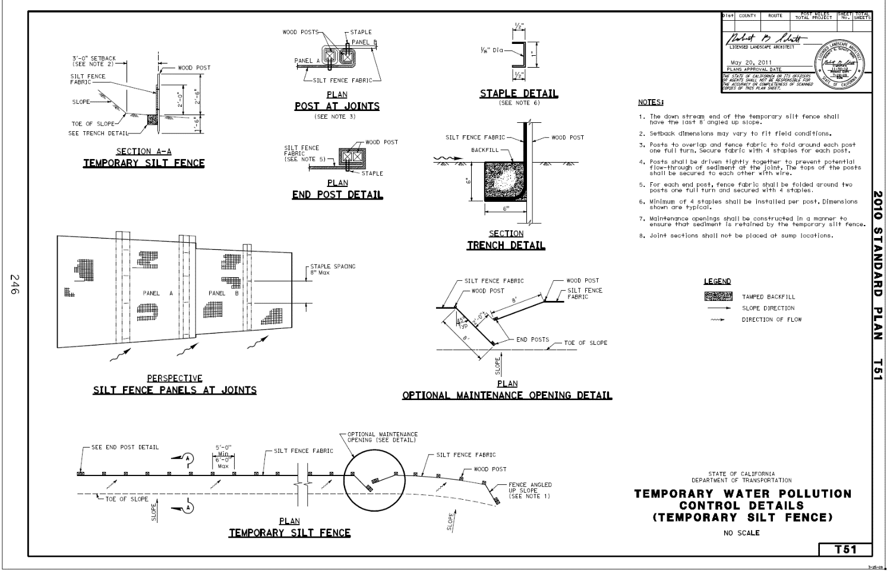

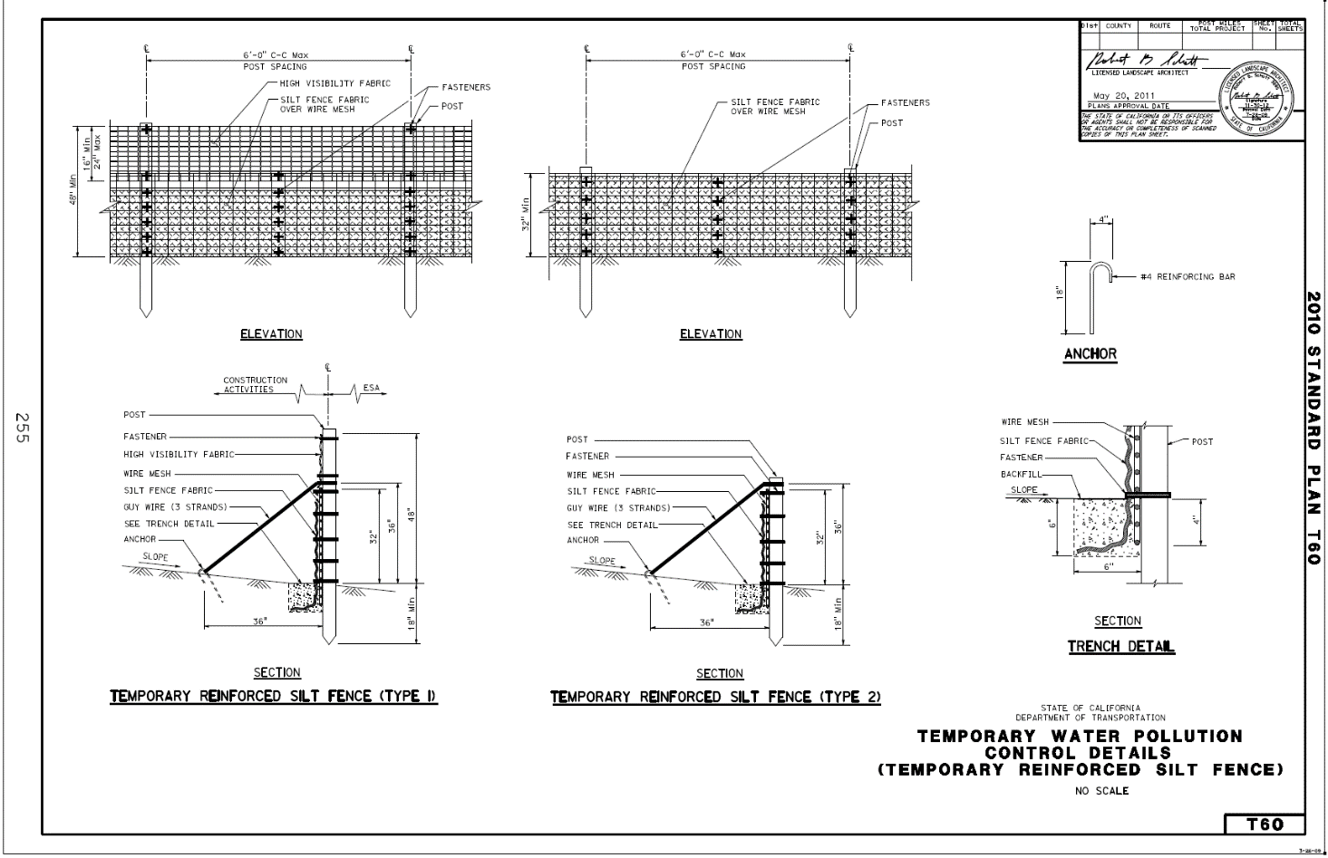

|  |  |
| --- | --- |
| **QUESTION** | **Application** |
| **SC4.1** | **Is the Temporary Check Dam applied as required (control of storm water through the site)?** |
| **CGP, Attachment C.F, D.F, E.F** | Risk Level 1, 2, 1nd 3 dischargers shall effectively manage all run-on, all runoff within the site and all runoff that discharges off the site. Run-on from off site shall be directed away from all disturbed areas or shall collectively be in compliance with the effluent limitations in this General Permit. |
| **LTP, VIII.B** | Dischargers shall implement a combination of sediment and erosion controls to prevent or minimize sediment discharges from the site. Control measures shall include, but are not limited to, the following items:  **2.** Install temporary gravel bag dikes, fiber rolls, filter fabric fence, or other equivalent measures as necessary to control erosion and runoff.  **3.** Install temporary check dams such as gravel bag dikes in concentrated flow lines to slow and detain water flows and retain sediment.  **8.** Control storm water volume and velocity within the site to minimize soil erosion and offsite discharges. |

|  |  |
| --- | --- |
|  | **Installation** |
| **SC4.2** | **Is the Type 1 (Fiber Roll) or Type 2 (Gravel Bag) Check Dam Temporary Check Dam installed properly?** |
| **SPECs, 13-6.03B Temporary Check Dams** | Before placing a temporary check dam, remove obstructions, including rocks, clods, and debris greater than 1 inch in diameter from the ground.  If a temporary check dam is to be placed in the same area as an erosion control blanket, install the blanket before placing the dam.  A temporary check dam must be:  1. Placed approximately perpendicular to the centerline of the ditch or drainage line  2. Installed with sufficient spillway depth to prevent flanking of concentrated flow around the ends of the check dam  3. Type 2 if the ditch is lined with concrete or HMA  4. Type 1 or Type 2 if the ditch is unlined  For a Type 1 temporary check dam:  1. Secure the fiber rolls with rope and notched wood stakes as shown.  2. Drive the stakes into the soil until the notch is even with the top of the fiber roll.  3. Lace rope between the stakes and over the fiber roll. Knot the rope at each stake.  4. Tighten by driving the stakes further into the soil and forcing the fiber roll against the surface of the ditch or drainage line.  Place a Type 2 temporary check dam as a single layer of gravel-filled bags, placed end-to-end to eliminate gaps. If you need to increase the height of the dam, add more layers of gravel-filled bags. Stack the bags in the upper row to overlap the joints in the lower row. Stabilize the rows by adding more rows of bags in the lower layers. |
| **See Standard Plan Sheet T57** | Temporary Check Dam |

|  |  |
| --- | --- |
|  | **Materials** |
| **SC4.3** | **Does the Temporary Check Dam consist of the proper materials (fiber roll, gravel bag)?** |
| **SPECs, 13-5.02G Gravel-Filled Bags** | Gravel-filled bags must:  1. Be made of geosynthetic gravel-filled bag.  2. Have inside dimensions from 24 to 32 inches long and from 16 to 20 inches wide.  3. Have a bound opening to keep gravel. The opening must be sewn with yarn, bound with wire, or secured with a closure device.  4. Weigh from 30 to 50 pounds when filled with gravel.  Gravel for gravel-filled bags must be from 3/8 to 3/4 inch in diameter and must be clean and free of clay balls, organic matter, and other deleterious materials. |
| **SPECs, 21-1.02P Fiber Rolls** | Fiber roll must have a minimum functional longevity of 1 year and comply with the following requirements:  1. Type A fiber roll must be fabricated from an erosion control blanket rolled along its width. Secure with natural fiber twine at 6-foot intervals, and 6 inches from each end. Fiber roll size must comply with either one of the following:  1.1. 8 to 10 inches in diameter, 10 to 20 feet long, and at least 0.5 lb/ft  1.2. 10 to 12 inches in diameter, at least 10 feet long, and at least 2 lb/ft  2. Type B fiber roll must be a premanufactured roll filled with rice or wheat straw, wood excelsior, or coconut fiber. Rolls must be covered with biodegradable jute, sisal, or coir fiber netting secured tightly at each end. Fiber roll size must comply with either one of the following:  2.1. 8 to 10 inches in diameter, 10 to 20 feet long, and at least 1.1 lb/ft  2.2. 10 to 12 inches in diameter, at least 10 feet long, and at least 3 lb/ft |
| **SPECs, 21-1.02R Fasteners** | Wood stakes must be untreated fir, redwood, cedar, or pine and cut from sound timber. The ends must be pointed for driving into the ground. Notched stakes must be at least 1 by 2 by 24 inches in size. Stakes without notches must be at least 1 by 1 by 24 inches.  Metal stakes must be at least 1/2 inch in diameter and have tops bent at 90-degree angles or capped with an orange or red plastic safety cap that fits snugly onto the metal stake.  Rope to fasten fiber rolls and compost socks must be 1/4 inch in diameter and biodegradable, such as sisal or manila. |

|  |  |
| --- | --- |
|  | **Maintenance** |
| **SC4.4** | **Is the Temporary Check Dam maintained properly?** |
| **CGP, Attachment D.E.6; E.E.6** | Risk Level 2 and 3 dischargers shall ensure that all storm drain inlets and perimeter controls, runoff control BMPs, and pollutant controls at entrances and exits (e.g. tire washoff locations) are maintained and protected from activities that reduce their effectiveness. |
| **CGP, Order IV.E Proper Operation and Maintenance** | The discharger shall at all times properly operate and maintain any facilities and systems of treatment and control (and related appurtenances) which are installed or used by the discharger to achieve compliance with the conditions of this General Permit. Proper operation and maintenance also includes adequate laboratory controls and appropriate quality assurance procedures. Proper operation and maintenance may require the operation of backup or auxiliary facilities or similar systems installed by a discharger when necessary to achieve compliance with the conditions of this General Permit. |

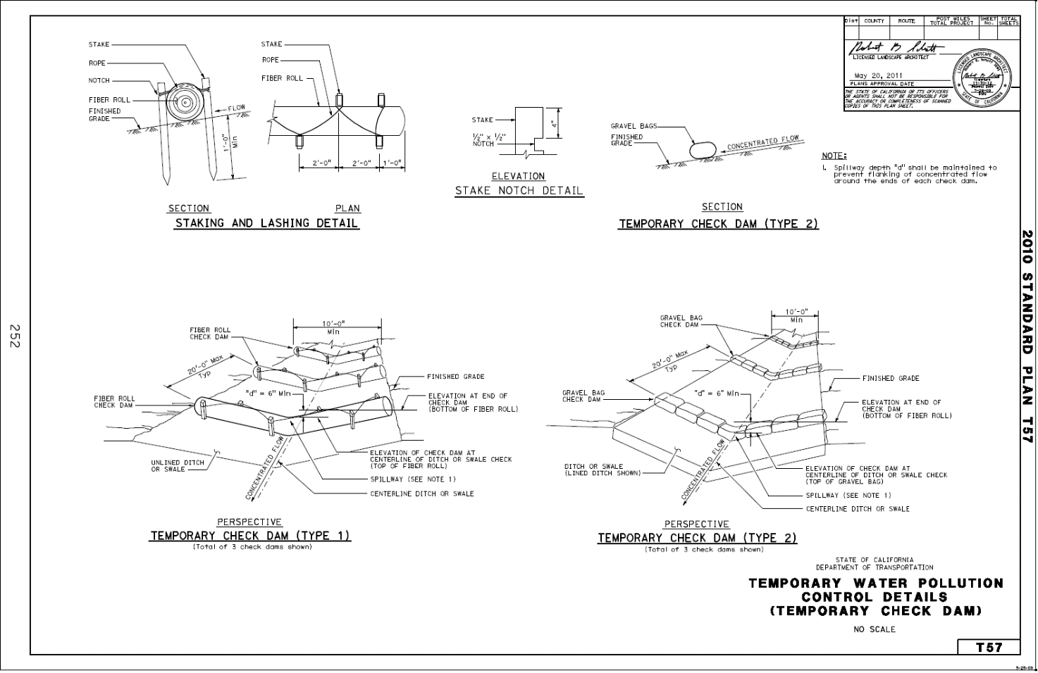

|  |  |
| --- | --- |
| **QUESTION** | **Application** |
| **SC5.1a** | **Are the Fiber Rolls applied as required - temporary linear barrier (perimeter control)?** |
| **CGP, Attachment C.E.1, D.E.1, E.E.1** | Risk Level 1, 2 and 3 dischargers shall establish and maintain effective perimeter controls and stabilize all construction entrances and exits to sufficiently control erosion and sediment discharges from the site. |
| **LTP, VIII, B** | Dischargers shall implement a combination of sediment and erosion controls to prevent or minimize sediment discharges from the site. Control measures shall include, but are not limited to, the following items:  **1.** Install temporary sediment controls for the down gradient perimeter of the project site, and/or any location where storm water or authorized non-stormwater may discharge from the project site, prior to the initiation of any construction related activities. |
| **SC5.1b** | **Are the Fiber Rolls applied as required - temporary slope interrupters (face of slope)?** |
| **CGP, Attachment D.E.4; E.E.4** | Risk Level 2 and 3 dischargers shall apply linear sediment controls along the toe of the slope, face of the slope, and at the grade breaks of exposed slopes. |

|  |  |
| --- | --- |
|  | **Installation** |
| **SC5.2a** | **Are the Fiber Rolls installed properly as temporary linear barrier (perimeter control)?** |
| **SPECs, 13-10.03D Temporary Large Sediment Barriers** | Install a temporary large sediment barrier as follows:  1. Place a single row of fiber rolls end-to-end approximately parallel with the slope contour. For any 20-foot section of fiber roll, do not allow the fiber roll to vary by more than 5 percent from level.  2. Place the fiber rolls in a furrow that is from 6 to 8 inches deep.  3. Secure the fiber rolls with wood stakes 4 feet apart.  4. Place a stake 18 inches from each end of each fiber roll.  5. Drive the stakes into the soil so that the top of the stakes are less than 2 inches above the top of the fiber rolls.  6. Angle the last 6 feet upslope at the downhill end of the run. |
| **SPECs, 21-1.03P Fiber Rolls** | Before installing fiber roll remove obstructions from the ground, including rocks, clods, and debris greater than 1 inch in diameter.  Type 1 fiber roll installation consists of placing and fastening as follows:  1. Place in a furrow that is from 2 to 4 inches deep.  2. Fasten with wood stakes every 4 feet along the length of the fiber roll.  3. Fasten the ends of the fiber roll by placing a stake 6 inches from the end of the roll.  4. Drive the stakes into the soil so that the top of the stake is less then 2 inches above the top of the fiber roll.  Type 2 fiber roll installation consists of placing and fastening as follows:  1. Fasten with notched wood stakes and rope.  2. Drive stakes into the soil until the notch is even with the top of the fiber roll.  3. Lace the rope between stakes and over the fiber roll. Knot the rope at each stake.  4. Tighten the fiber roll to the surface of the slope by driving the stakes further into the soil. |
| **See Standard Plan Sheet T66** | Temporary Large Sediment Barrier |
| **SC5.2b** | **Are the Fiber Rolls installed properly as temporary slope interrupters (face of slope)?** |
| **SPECs, 21-1.03P Fiber Rolls** | Install fiber roll approximately parallel to the slope contour. For any 20-foot section of fiber roll, prevent the fiber roll from varying more than 5 percent from level. Install fiber roll on slopes at the following spacing unless shown otherwise:  1. 10 feet apart for slopes steeper than 2:1 (horizontal:vertical)  2. 15 feet apart for slopes from 2:1 to 4:1 (horizontal:vertical)  3. 20 feet apart for slopes from 4:1 to 10:1 (horizontal:vertical)  4. 50 feet apart for slopes flatter than 10:1 (horizontal:vertical) |
| **SPECs, 21-1.03P Fiber Rolls** | As specified for Type 1 and Type 2 fiber roll installations above in **temporary linear barrier (perimeter control)**. |
| **See Standard Plan Sheet T56** | Temporary Fiber Roll |

|  |  |
| --- | --- |
|  | **Materials** |
| **SC5.3** | **Do Fiber Rolls consist of the proper materials?** |
| **SPECs, 13-10.02B Fiber Roll** | Fiber rolls for a large sediment barrier must be Type B, except the dimensions must be from 18 to 22 inches in diameter, at least 8 feet long, and weigh at least 6.5 pounds per linear foot. |

|  |  |
| --- | --- |
| **SPECs, 13-10.02C Posts** | Do not use metal posts for a temporary large sediment barrier.  Wood posts must be:  1. At least 2 by 2 inches in size and 4 feet long  2. Untreated fir, redwood, cedar, or pine, cut from sound timber  3. Straight and free of loose or unsound knots and other defects that could render the posts unfit for use  4. Pointed on the end to be driven into the ground |

|  |  |
| --- | --- |
| **SPECs, 21-1.02P Fiber Rolls** | Fiber roll must have a minimum functional longevity of 1 year and comply with the following requirements:  1: Type A fiber roll must be fabricated from an erosion control blanket rolled along its width. Secure with natural fiber twine at 6-foot intervals, and 6 inches from each end. Fiber roll size must comply with either one of the following:  1.1: 8 to 10 inches in diameter, 10 to 20 feet long, and at least 0.5 lb/ft  1.2: 10 to 12 inches in diameter, at least 10 feet long, and at least 2 lb/ft  2: Type B fiber roll must be a pre-manufactured roll filled with rice or wheat straw, wood excelsior, or coconut fiber. Rolls must be covered with biodegradable jute, sisal, or coir fiber netting secured tightly at each end. Fiber roll size must comply with either one of the following:  2.1: 8 to 10 inches in diameter, 10 to 20 feet long, and at least 1.1 lb/ft  2.2: 10 to 12 inches in diameter, at least 10 feet long, and at least 3 lb/ft |
| **SPECs, 21-1.02R Fasteners** | Wood stakes must be untreated fir, redwood, cedar, or pine and cut from sound timber. The ends must be pointed for driving into the ground. Notched stakes must be at least 1 by 2 by 24 inches in size. Stakes without notches must be at least 1 by 1 by 24 inches. Metal stakes must be at least 1/2 inch in diameter and have tops bent at 90-degree angles or capped with an orange or red plastic safety cap that fits snugly onto the metal stake. Rope to fasten fiber rolls and compost socks must be 1/4 inch in diameter and biodegradable, such as sisal or manila. |

|  |  |
| --- | --- |
|  | **Maintenance** |
| **SC5.4** | **Are the Fiber Rolls maintained properly?** |
| **SPECs, 13-10.03A General** | Maintain a temporary linear sediment barrier to provide sediment-holding capacity and to reduce concentrated flow velocities.  Repair or adjust the barrier whenever rills and other evidence of concentrated runoff are occurring beneath the barrier.  Repair or replace split, torn, or unraveled material.  Remove sediment deposits, trash, and other debris as needed or ordered.  Whenever you place the removed sediment deposits within the job site, stabilize the sediment deposits to prevent erosion. |
| **CGP, Attachment C.E.1, D.E.1, E.E.1** | Risk Level 1, 2 and 3 dischargers shall establish and maintain effective perimeter controls and stabilize all construction entrances and exits to sufficiently control erosion and sediment discharges from the site. |
| **CGP, Attachment D.E.6; E.E.6** | Risk Level 2 and 3 dischargers shall ensure that all storm drain inlets and perimeter controls, runoff control BMPs, and pollutant controls at entrances and exits (e.g. tire washoff locations) are maintained and protected from activities that reduce their effectiveness. |
| **CGP, Order IV.E Proper Operation and Maintenance** | The discharger shall at all times properly operate and maintain any facilities and systems of treatment and control (and related appurtenances) which are installed or used by the discharger to achieve compliance with the conditions of this General Permit. Proper operation and maintenance also includes adequate laboratory controls and appropriate quality assurance procedures. Proper operation and maintenance may require the operation of backup or auxiliary facilities or similar systems installed by a discharger when necessary to achieve compliance with the conditions of this General Permit. |

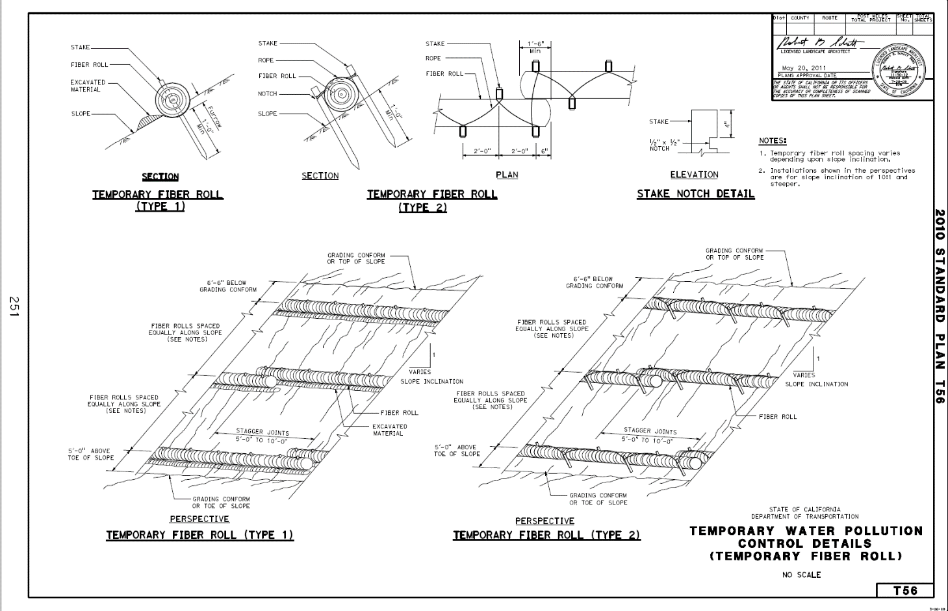

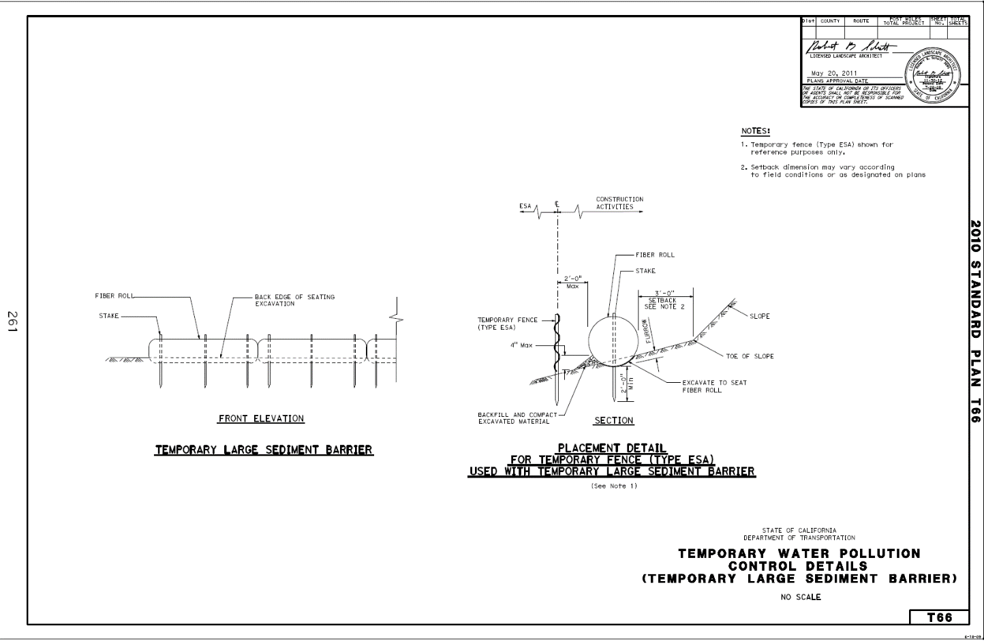

|  |  |
| --- | --- |
| **QUESTION** | **Application** |
| **SC6.1a** | **Is the Temporary Gravel Bag Berm applied as required - temporary linear barrier (perimeter control)?** |
| **CGP, Attachment C.E.1, D.E.1, E.E.1** | Risk Level 1, 2 and 3 dischargers shall establish and maintain effective perimeter controls and stabilize all construction entrances and exits to sufficiently control erosion and sediment discharges from the site. |
| **LTP, VIII, B** | Dischargers shall implement a combination of sediment and erosion controls to prevent or minimize sediment discharges from the site. Control measures shall include, but are not limited to, the following items:  **1.** Install temporary sediment controls for the down gradient perimeter of the project site, and/or any location where storm water or authorized non-stormwater may discharge from the project site, prior to the initiation of any construction related activities. |
| **SC6.1b** | **Is the Temporary Gravel Bag Berm applied as required - temporary slope interrupters (face of slope)?** |
| **CGP, Attachment D.E.4; E.E.4** | Risk Level 2 and 3 dischargers shall apply linear sediment controls along the toe of the slope, face of the slope, and at the grade breaks of exposed slopes. |

|  |  |
| --- | --- |
|  | **Installation** |
| **SC6.2a** | **Is the Temporary Gravel Bag Berm installed properly as temporary linear barrier (perimeter control)?** |
| **SPECs, 13-10.03A General** | Before installing a temporary linear sediment barrier, remove obstructions, including rocks, clods, and debris greater than 1 inch in diameter from the ground.  Place gravel-filled bags behind Type K temporary railing if used within the shoulder area. |
| **SPECs, 13-10.03C Temporary Gravel Bag Berms** | Place the bags end-to-end to eliminate gaps. Place bags approximately parallel with the slope contour. Angle the last 6 feet upslope at the downhill end of the run. Stack the bags so that the upper row overlaps joints in the lower row.  If you need to increase the height of a temporary gravel bag berm, add more layers of gravel-filled bags. Stack the bags in the upper row to overlap the joints in the lower row. Stabilize the rows by adding more rows of bags in the lower layers. |
| **SC6.2b** | **Is the Temporary Gravel Bag Berm installed properly as temporary slope interrupters (face of slope)?** |
| **CGP, Attachment D.E.4; E.E.4** | Risk Level 2 and 3 dischargers shall apply linear sediment controls along the toe of the slope, face of the slope, and at the grade breaks of exposed slopes to comply with sheet flow lengths in accordance with Table 1.  Table 1-Critical Slope/Sheet Flow Length Combinations  Slope Percentage Sheet flow length not to exceed  0 - 25% 20 feet  25-50% 15 feet  Over 50% 10 feet |
| **SPECs, 13-10.03A General** | As specified for installation above in **temporary linear barrier (perimeter control)**. |
| **SPECs, 13-10.03C Temporary Gravel Bag Berms** | As specified for installation above in **temporary linear barrier (perimeter control)**. |

|  |  |
| --- | --- |
|  | **Materials** |
| **SC6.3** | **Does the Temporary Gravel Bag Berm consist of the proper materials?** |
| **SPECs, 13-5.02G Gravel-Filled Bags** | Gravel-filled bags must:  1. Be made of geosynthetic gravel-filled bag.  2. Have inside dimensions from 24 to 32 inches long and from 16 to 20 inches wide.  3. Have a bound opening to keep gravel. The opening must be sewn with yarn, bound with wire, or secured with a closure device.  4. Weigh from 30 to 50 pounds when filled with gravel.  Gravel for gravel-filled bags must be from 3/8 to 3/4 inch in diameter and must be clean and free of clay balls, organic matter, and other deleterious materials. |

|  |  |
| --- | --- |
|  | **Maintenance** |
| **SC6.4** | **Is the Temporary Gravel Bag Berm maintained properly?** |
| **SPECs, 13-10.03A General** | Maintain a temporary linear sediment barrier to provide sediment-holding capacity and to reduce concentrated flow velocities.  Repair or adjust the barrier whenever rills and other evidence of concentrated runoff are occurring beneath the barrier.  Repair or replace split, torn, or unraveled material.  Remove sediment deposits, trash, and other debris as needed or ordered.  Whenever you place the removed sediment deposits within the job site, stabilize the sediment deposits to prevent erosion. |
| **CGP, Attachment C.E.1, D.E.1, E.E.1** | Risk Level 1, 2 and 3 dischargers shall establish and maintain effective perimeter controls and stabilize all construction entrances and exits to sufficiently control erosion and sediment discharges from the site. |
| **CGP, Attachment D.E.6; E.E.6** | Risk Level 2 and 3 dischargers shall ensure that all storm drain inlets and perimeter controls, runoff control BMPs, and pollutant controls at entrances and exits (e.g. tire washoff locations) are maintained and protected from activities that reduce their effectiveness. |
| **CGP, Order IV.E Proper Operation and Maintenance** | The discharger shall at all times properly operate and maintain any facilities and systems of treatment and control (and related appurtenances) which are installed or used by the discharger to achieve compliance with the conditions of this General Permit. Proper operation and maintenance also includes adequate laboratory controls and appropriate quality assurance procedures. Proper operation and maintenance may require the operation of backup or auxiliary facilities or similar systems installed by a discharger when necessary to achieve compliance with the conditions of this General Permit. |

|  |  |
| --- | --- |
| **QUESTION** | **Application** |
| **SC7.1** | **Is Street Sweeping applied as required?** |
| **SPECs, 13-4.03F Sweeping** | Sweep paved roads at construction entrance and exit locations and paved areas within the job site:  1. During clearing and grubbing activities  2. During earthwork activities  3. During trenching activities  4. During pavement structure activities  5. When vehicles are entering and leaving the job site  6. After soil-disturbing activities  7. After observing off-site tracking of material  Monitor paved areas and roadways within the project. Sweep within:  1. 1 hour whenever sediment or debris is observed during activities that require sweeping  2. 24 hours whenever sediment or debris is observed during activities that do not require sweeping |
| **SPECs, 13-7.03A General** | When material is tracked onto the pavement, remove it within 6 hours, unless the Engineer authorizes a longer period. **(At a stabilized construction exit/entrance)** |
| **SPECs, 13-7.03D Street Sweeping** | At least 1 street sweeper must be kept at the job site at all times when street sweeping work is required. The street sweeper must be in good working order. |
| **CGP, Attachment C.E.6, D.E.6, E.E.6** | Risk Level 2 and 3 dischargers shall inspect on a daily basis all immediate access roads daily. At a minimum daily (when necessary) and prior to a rain event, the discharger shall remove any sediment or other construction activity-related materials that are deposited on the roads (by vacuuming or sweeping). |

|  |  |
| --- | --- |
|  | **Implementation** |
| **SC7.2** | **Is Street Sweeping implemented properly?** |
| **SPECs, 13-4.03F Sweeping** | Sweep by hand or mechanical methods, such as vacuuming. Do not use methods that use only mechanical kick brooms.  Remove collected material, including sediment, from paved shoulders, drain inlets, curbs and dikes, and other drainage areas. You may stockpile collected material at the job site. Dispose of collected material at least once per week if stockpiled.  You may dispose of sediment within the job site collected during sweeping activities. Protect the disposal areas against erosion.  Keep dust to a minimum during street sweeping activities. Use water or a vacuum whenever dust generation is excessive or sediment pickup is ineffective. Remove and dispose of trash collected during sweeping. |
| **SPECs, 13-7.02A Materials** | The street sweeper must be one of the following:  1. Mechanical sweeper followed by a vacuum-assisted sweeper  2. Vacuum-assisted dry, waterless, sweeper3. Regenerative-air sweeper |
| **CGP, Order A.6** | Discharge of wastes or wastewater from road-sweeping vehicles or from other maintenance activities to any waters of the United States or to any storm drain leading to waters of the United States is prohibited unless in compliance with section E.2.h.3)c)ii) of this Order or authorized by another NPDES permit. |
| **CGP, Attachment C.C.3; D.C.3; E.C.3** | Risk Level 1, 2 and 3 dischargers shall clean streets in such a manner as to prevent unauthorized non-storm water discharges from reaching surface water or MS4 drainage systems. |
| **CGP, Order IV.E Proper Operation and Maintenance** | The discharger shall at all times properly operate and maintain any facilities and systems of treatment and control (and related appurtenances) which are installed or used by the discharger to achieve compliance with the conditions of this General Permit. Proper operation and maintenance also includes adequate laboratory controls and appropriate quality assurance procedures. Proper operation and maintenance may require the operation of backup or auxiliary facilities or similar systems installed by a discharger when necessary to achieve compliance with the conditions of this General Permit. |

|  |  |
| --- | --- |
| **QUESTION** | **Application** |
| **SC9.1** | **Is the Temporary Straw Bale Barrier applied as required - temporary linear barrier (perimeter control)?** |
| **CGP, Attachment C.E.1, D.E.1, E.E.1** | Risk Level 1, 2 and 3 dischargers shall establish and maintain effective perimeter controls and stabilize all construction entrances and exits to sufficiently control erosion and sediment discharges from the site. |

|  |  |
| --- | --- |
|  | **Installation** |
| **SC9.2** | **Is the Temporary Straw Bale Barrier installed properly?** |
| **SPECs, 13-10.03A General** | Before installing a temporary linear sediment barrier, remove obstructions, including rocks, clods, and debris greater than 1 inch in diameter from the ground. |
| **SPECs, 13-10.03G Temporary Straw Bale Barriers** | Install a temporary straw bale barrier as follows:  1. Place a single row of straw bales end-to-end parallel with the slope contour. For any 20-foot section of straw bale barrier, do not allow it to vary by more than 5 percent from level.  2. Place straw bales in a trench or keyed into the slope. Place the bales so that the binding wire or string does not come in contact with the soil.  3. Secure each straw bale with 2 stakes. The first stake in each bale must be driven toward the previously laid bale to force the bales together.  4. Drive the stakes into the soil so that the top of the stake is less than 2 inches above the top of the straw bale.  5. Angle the last 6 feet upslope at the downhill end of the run. |
| **See Standard Plan Sheet T52** | Temporary Straw Bale Barrier |

|  |  |
| --- | --- |
|  | **Materials** |
| **SC9.3** | **Does the Temporary Straw Bale Barrier consist of the proper materials?** |
| SPECs, 13-10.02H Straw Bales | Straw bales must be:  1. At least 14 inches wide, 18 inches high, 36 inches long, and weigh at least 50 pounds.  2. Composed entirely of vegetative matter except for the binding material.  3. Bound by wire, nylon, or polypropylene string. Do not use jute or cotton binding. Baling wire must be at least 16 gauge. Nylon or polypropylene string must be approximately 0.08 inch in diameter with 80 pounds of breaking strength. |
| **SPECs, 13-10.02C Posts** | Posts used as stakes for a temporary straw-bale barrier must be wood or metal.  Wood posts must be:  1. At least 2 by 2 inches in size and 4 feet long  2. Untreated fir, redwood, cedar, or pine, cut from sound timber  3. Straight and free of loose or unsound knots and other defects that could render the posts unfit for use  4. Pointed on the end to be driven into the ground  Metal posts must:  1. Be at least 4 feet long.  2. Be made of steel.  3. Have a U-shaped, T-shaped, L-shaped, or other cross-sectional shape that can resist failure from lateral loads.  4. Be pointed on the end to be driven into the ground.  5. Weigh at least 0.75 pound per foot.  6. Have a safety cap attached to the exposed end. The safety cap must be orange or red plastic and must fit snugly onto the metal post. |
| **SPECs, 21-1.02I Straw** | Straw must be stalks from wheat, rice, or barley furnished in air-dry condition with a consistency compatible for application with commercial straw-blowing equipment. Wheat and barley straw must be derived from irrigated crops.  Straw must be free of plastic, glass, metal, rocks, and refuse or other deleterious material.  Straw must have not have been used for stable bedding. |

|  |  |
| --- | --- |
|  | **Maintenance** |
| **SC9.4** | **Is the Temporary Straw Bale Barrier maintained properly?** |
| **SPECs, 13-10.03A General** | Maintain a temporary linear sediment barrier to provide sediment-holding capacity and to reduce concentrated flow velocities.  Repair or adjust the barrier whenever rills and other evidence of concentrated runoff are occurring beneath the barrier.  Repair or replace split, torn, or unraveled material.  Remove sediment deposits, trash, and other debris as needed or ordered.  Whenever you place the removed sediment deposits within the job site, stabilize the sediment deposits to prevent erosion. |
| **CGP, Attachment C.E.1, D.E.1, E.E.1** | Risk Level 1, 2 and 3 dischargers shall establish and maintain effective perimeter controls and stabilize all construction entrances and exits to sufficiently control erosion and sediment discharges from the site. |
| **CGP, Attachment D.E.6; E.E.6** | Risk Level 2 and 3 dischargers shall ensure that all storm drain inlets and perimeter controls, runoff control BMPs, and pollutant controls at entrances and exits (e.g. tire washoff locations) are maintained and protected from activities that reduce their effectiveness. |
| **CGP, Order IV.E Proper Operation and Maintenance** | The discharger shall at all times properly operate and maintain any facilities and systems of treatment and control (and related appurtenances) which are installed or used by the discharger to achieve compliance with the conditions of this General Permit. Proper operation and maintenance also includes adequate laboratory controls and appropriate quality assurance procedures. Proper operation and maintenance may require the operation of backup or auxiliary facilities or similar systems installed by a discharger when necessary to achieve compliance with the conditions of this General Permit. |

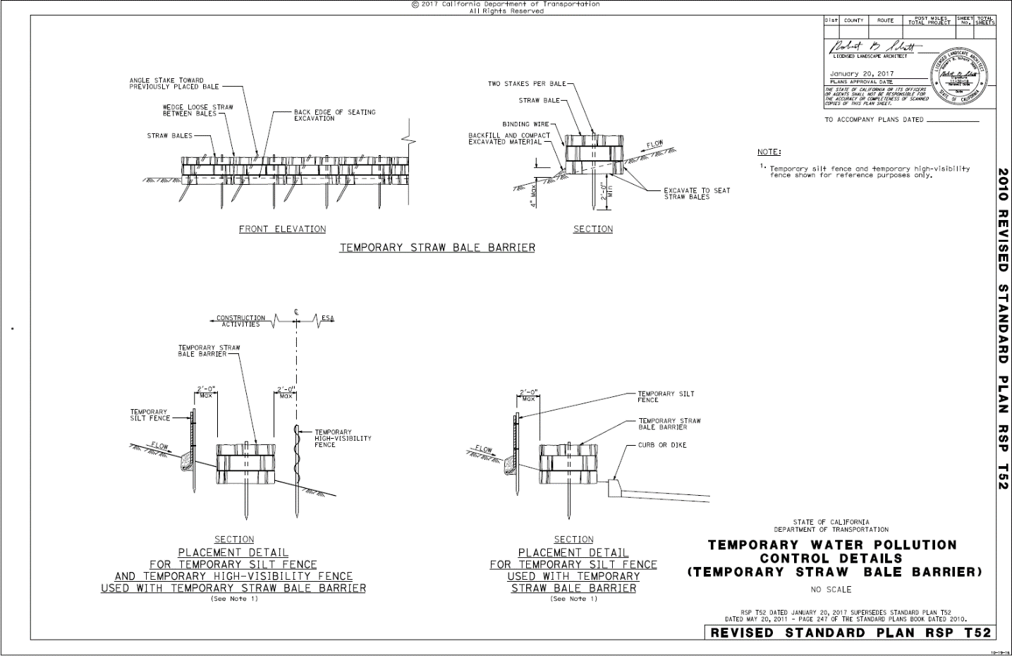

|  |  |
| --- | --- |
| **QUESTION** | **Application** |
| **SC10.1** | **Is the Drain Inlet Protection applied as required?** |
| **SPECs, 13-6.03C Temporary Drainage Inlet Protection** | Provide temporary drainage inlet protection around drainage inlets as changing conditions require. |
| **LTP, VIII.B** | Dischargers shall implement a combination of sediment and erosion controls to prevent or minimize sediment discharges from the site. Control measures shall include, but are not limited to, the following items:  **4.** Protect drain inlets and outfall structures with appropriate controls for erosion and to minimize sediment discharges. |

|  |  |
| --- | --- |
|  | **Installation** |
| **SC10.2** | **Is the Drain Inlet Protection installed properly?** |
| **SPECs, 13-6.03C Temporary Drainage Inlet Protection** | Drainage inlet protection must be Type 1, Type 2, Type 3A, Type 3B, Type 4A, Type 4B, Type 5, Type 6A, Type 6B, or a combination, as appropriate for conditions around the drainage inlet.  For drainage inlet protection at drainage inlets in paved and unpaved areas:  1. Prevent runoff ponds from encroaching onto the traveled way or overtopping the curb or dike. Use a linear sediment barrier to redirect runoff and control ponding.  2. Clear the area around each drainage inlet of obstructions, including rocks, clods, and debris greater than 1 inch in diameter, before installing the drainage inlet protection.  3. Install the linear sediment barrier upslope of the existing drainage inlet and parallel with the curb, dike, or flow line to prevent sediment from entering the drainage inlet  If gravel-filled bags are used for Type 3A and Type 3B temporary drainage inlet protection, place the gravel-filled bags end-to-end to eliminate gaps. Stack the bags so that the upper row overlaps joints in the lower row. Arrange the bags to create a spillway by removing 1 or more gravel-filled bags from the upper layer.  Place fiber rolls over the erosion control blanket for Type 4A temporary drainage inlet protection.  If a foam barrier is used for Type 4B temporary drainage inlet protection, secure the barrier to the pavement at the angle and spacing shown. Place the barrier to provide a tight joint with the curb or dike. Cut the cover fabric or jacket to ensure a tight fit.  If a rigid sediment barrier is used for Type 6A or Type 6B temporary drainage inlet protection at a grated catch basin without a curb inlet, place the barrier using a gasket to prevent runoff from flowing under the barrier. Secure the barrier to the pavement with nails and adhesive, gravel-filled bags, or a combination.  Install a sediment filter bag for Type 5 temporary drainage inlet protection as follows:  1. Remove the drainage inlet grate  2. Place the sediment filter bag in the opening  3. Replace the grate to secure the sediment filter bag in place |
| **SPECs, 13-6.02B Rigid Plastic Barriers** | For a curb inlet without a grate, rigid plastic barriers must be sized to fit the catch basin or drainage inlet and have:  1. Horizontal flap of at least 6 inches with an under-seal gasket to prevent underflows 2. High-flow bypass 3. Vertical height of at least 7 inches after installation  For a grated catch basin without a curb inlet, rigid plastic barriers must be sized to fit the catch basin or drainage inlet and:  1. Cover the grate by at least 2 inches on each side and have an under-seal gasket to prevent underflows  2. Have a high-flow bypass  3. Have a vertical height of at least 1.5 inches after installation  For a curb inlet with a grate, rigid plastic barriers must be sized to fit the catch basin or drainage inlet and have:  1. Horizontal flap that covers the grate by at least 2 inches on the 3 sides that are away from the curb opening and must have an under-seal gasket to prevent underflows  2. High-flow bypass  3. Vertical section that covers the curb opening by at least 5 inches after installation |
| **SPECs, 13-10.02I Foam Barriers** | Secure foam barriers to:  1. Pavement with 1-inch concrete nails, 1-inch washers, and solvent-free adhesive  2. Soil with 6-inch nails and 1-inch washers |
| **SPECs, 13-10.03H Temporary Foam Barriers** | Secure temporary foam barriers to the pavement with nails and adhesive, gravel-filled bags, or a combination.  Install the foam barrier with a horizontal flap in a 3-inch deep trench and secure with nails and washers placed not more than 4 feet apart. Secure the barrier with 2 nails at the connection points where barriers overlap. Do not pierce the barrier’s core with nails or stakes. |
| **See Standard Plan Sheet T61** | Temporary Drainage Inlet Protection |
| **See Standard Plan Sheet T62** | Temporary Drainage Inlet Protection |
| **See Standard Plan Sheet T63** | Temporary Drainage Inlet Protection |
| **See Standard Plan Sheet T64** | Temporary Drainage Inlet Protection |

|  |  |
| --- | --- |
|  | **Materials** |
| **SC10.3** | **Does the Drain Inlet Protection consist of the proper materials (gravel-filled bag, rigid plastic barrier, sediment filter bag, foam barrier, erosion control blanket)?** |
| **SPECs, 13-10.02C Posts** | Posts must be wood or metal.  Wood posts must be:  1. At least 2 by 2 inches in size and 4 feet long  2. Untreated fir, redwood, cedar, or pine, cut from sound timber  3. Straight and free of loose or unsound knots and other defects that could render the posts unfit for use  4. Pointed on the end to be driven into the ground  Metal posts must:  1. Be at least 4 feet long.  2. Be made of steel.  3. Have a U-shaped, T-shaped, L-shaped, or other cross-sectional shape that can resist failure from lateral loads.  4. Be pointed on the end to be driven into the ground.  5. Weigh at least 0.75 pound per foot.  6. Have a safety cap attached to the exposed end. The safety cap must be orange or red plastic and must fit snugly onto the metal post.  Posts for a temporary reinforced silt fence must be at least 6 feet in length for a Type 1 installation and 5 feet in length for a Type 2 installation. |
| **SPECs, 13-10.02B Fiber Roll** | Fiber rolls for a large sediment barrier must be Type B, except the dimensions must be from 18 to 22 inches in diameter, at least 8 feet long, and weigh at least 6.5 pounds per linear foot. |
| **SPECs, 21-1.02P Fiber Rolls** | Fiber roll must have a minimum functional longevity of 1 year and comply with the following requirements:  1. Type A fiber roll must be fabricated from an erosion control blanket rolled along its width. Secure with natural fiber twine at 6-foot intervals, and 6 inches from each end. Fiber roll size must comply with either one of the following:  1.1: 8 to 10 inches in diameter, 10 to 20 feet long, and at least 0.5 lb/ft  1.2: 10 to 12 inches in diameter, at least 10 feet long, and at least 2 lb/ft  2: Type B fiber roll must be a premanufactured roll filled with rice or wheat straw, wood excelsior, or coconut fiber. Rolls must be covered with biodegradable jute, sisal, or coir fiber netting secured tightly at each end. Fiber roll size must comply with either one of the following:  2.1: 8 to 10 inches in diameter, 10 to 20 feet long, and at least 1.1 lb/ft  2.2: 10 to 12 inches in diameter, at least 10 feet long, and at least 3 lb/ft |
| **SPECs, 21-1.02R Fasteners** | Wood stakes must be untreated fir, redwood, cedar, or pine and cut from sound timber. The ends must be pointed for driving into the ground. Notched stakes must be at least 1 by 2 by 24 inches in size. Stakes without notches must be at least 1 by 1 by 24 inches.  Metal stakes must be at least 1/2 inch in diameter and have tops bent at 90-degree angles or capped with an orange or red plastic safety cap that fits snugly onto the metal stake.  Rope to fasten fiber rolls and compost socks must be 1/4 inch in diameter and biodegradable, such as sisal or manila. |
| **SPECs, 13-5.02G Gravel-Filled Bags** | Gravel-filled bags must:  1. Be made of geosynthetic gravel-filled bag.  2. Have inside dimensions from 24 to 32 inches long and from 16 to 20 inches wide.  3. Have a bound opening to keep gravel. The opening must be sewn with yarn, bound with wire, or secured with a closure device.  4. Weigh from 30 to 50 pounds when filled with gravel.  Gravel for gravel-filled bags must be from 3/8 to 3/4 inch in diameter and must be clean and free of clay balls, organic matter, and other deleterious materials. |
| **SPECs, 13-6.02B Rigid Plastic Barriers** | A rigid plastic barrier must:  1. Have an integrated filter  2. Have a formed outer jacket of perforated HDPE or polyethylene terephthalate  3. Have a flattened tubular-shaped cross section  4. Be made from virgin or recycled materials  5. Be free from biodegradable filler materials that degrade the physical or chemical characteristics of the completed filter core or outer jacket  6. Have a length of at least 4 feet per unit  7. Have the ability to interlock separate units into a long barrier so that water does not flow between the units  8. Be secured to:  8.1. Pavement with 1-inch concrete nails with 1-inch washers and solvent-free adhesive, gravel-filled bags, or a combination  8.2. Soil with 6-inch nails with 1-inch washers and wood stakes |
| **SPECs, 13-6.02C Sediment Filter Bags** | Each sediment filter bag must be sized to fit the catch basin or drainage inlet and have a high-flow bypass.  Sediment filter bags may include a metal frame. If the sediment filter bag does not have a metal frame and is deeper than 18 inches, it must include lifting loops, dump straps, and a restraint cord to keep the sides of the bag away from the walls of the catch basin. |
| **SPECs, 13-10.02I Foam Barriers** | Foam barriers must have:  1. Urethane foam-filled core  2. Geosynthetic fabric cover and flap  3. Triangular, circular, or square cross section  4. Vertical height of at least 5 inches after installation  5. Horizontal flap at least 8 inches in width  6. A length of at least 4 feet per unit  7. Ability to interlock separate units into a long barrier so that water will not flow between units |
| **SPECs, 21-1.02O(4) Erosion Control Blankets** | Erosion control blanket must be made of processed natural fibers that are mechanically, structurally, or chemically bound together to form a continuous matrix that is surrounded by 2 natural nets. The erosion control blanket must comply with the requirements shown in the following table:   |  |  |  |  | | --- | --- | --- | --- | | **Erosion Control Blanket** | | | | | **Property** | **Type** | **Requirements** | **Test Method** | | Classification | -- | ECTC Type 2D | -- | | Net type | A, B, C | Natural | -- | | Number of nets | A, B, C | Double | -- | | Minimum roll width | A, B, C | 72 inches | -- | | Matrix | A | 70/30% (straw/coconut fiber) | -- | | B | 100% woven coir (coconut fiber) | | C | Wood excelsior (80 percent of the fiber 6 inches or longer) | | Functional longevity | A, B, C | 12 months | -- | |
| **SPECs, 21-1.02R Fasteners** | Steel staples must be a minimum of 11-gauge, 6-inch, U-shaped staples with a 1-inch crown. Provide heavier gauge and greater length if required by the site conditions. You may use an alternative CGP, Attachment device such as a 100 percent biodegradable fastener to install RECP instead of staples. |

|  |  |
| --- | --- |
|  | **Maintenance** |
| **SC10.4** | **Is the Drain Inlet Protection maintained properly?** |
| **SPECs, 13-6.03A General** | Remove sediment deposits whenever the sediment exceeds 1 inch in depth from the surface of an erosion control blanket.  Remove sediment from a Type 2 sediment trap of a temporary inlet whenever the volume has been reduced by approximately 1/2.  Remove sediment from a sediment filter bag whenever it becomes full or whenever the restraint cords are no longer visible. Empty a sediment filter bag without a metal frame by placing 1-inch steel reinforcing bars through the lifting loops and lifting the filled bag from the drainage inlet. Empty a sediment filter bag with a metal frame by lifting the metal frame from the drainage inlet. Rinse the sediment filter bag before replacing it at the drainage inlet. Whenever rinsing a sediment filter bag, do not allow the rinse water to enter a drainage inlet or waterway.  Whenever you place the removed sediment within the job site, stabilize the sediment deposits to prevent erosion. |
| **CGP, Attachment D.E.6; E.E.6** | Risk Level 2 and 3 dischargers shall ensure that all storm drain inlets and perimeter controls, runoff control BMPs, and pollutant controls at entrances and exits (e.g. tire washoff locations) are maintained and protected from activities that reduce their effectiveness. |
| **CGP, Order IV.E Proper Operation and Maintenance** | The discharger shall at all times properly operate and maintain any facilities and systems of treatment and control (and related appurtenances) which are installed or used by the discharger to achieve compliance with the conditions of this General Permit. Proper operation and maintenance also includes adequate laboratory controls and appropriate quality assurance procedures. Proper operation and maintenance may require the operation of backup or auxiliary facilities or similar systems installed by a discharger when necessary to achieve compliance with the conditions of this General Permit. |



